Julia B. Moore, CPA
2195 Terrapin Creek Rd.
Lynch Station, VA 24571

December 9, 2020

Leesville Lake Association, INC.
PO Box 68
Altavista, VA 24517

Dear President Dave Rives and Board of Directors:

On December 9, 2020 Anne Waterman and I examined Leesville Lake Association’s financial records for the fiscal year September 1, 2019 through August 31, 2020 with emphasis on cash receipts and disbursements. I also had done a very brief review of the tax return before submission.

Mary’s records are outstanding. All the documents we requested were available and the transactions were well documented and easy to track. Four questions from last year have all been resolved.

Anne and I would like to thank Mary for her efforts to make the review as easy as possible. We would also like to thank the Board for the opportunity to help.

Best regards,

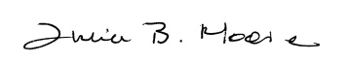

Julie Moore
Anne Waterman

