Minutes of Board Meeting,
Leesville Lake Association, September 8, 2022, Altavista Library

Present: Bill Beckett, Tony Capuco, Charlie Hamilton, Joe Humphrey, Pam McMillan, Dave Waterman, Richard Beaton, Dave Rives, Dannie Smith
Absent: J. W. Burton, Roy Kelley, Brian Bell, Mary Loiselle, Frank Podrebarac, Chip Zimmerman
Quorum: Yes
Guest: Doris (Liz) Cousins
Call to order: President, Dave Rives called the Board meeting to order at 6:35 p.m.

Minutes: Dave asked for a motion to approve the minutes from the August 11, 2022 Board meeting.
Motion: All approved.

Guest Introduction: Dave introduced Doris (Liz) Cousins as potential Secretary and Director. She introduced herself and described some experience:
- 26 years in military - Air Force (Retired)
- Altavista YMCA, Finch & Finch Funeral Home
- Lives at the Lake
For her benefit, the Board meeting process overview was reviewed and all Directors introduced themselves.

Treasurer’s Report:
Bill Beckett - presented the Treasurer’s report and highlighted items for year-end that were different by significant amounts from the budget. Since this is the fiscal year end, this was presented as such.
Pam asked for clarification: What was the increase cost for beautification day?
2K increase. Dave requested that Bill provide more information to the board at the next meeting.
Motion to approve the August Treasurer’s Report: All approved.

Committee Reports:
Executive: Dave R had a good conversation with Cynthia Coleman regarding her interest in helping the organization. She is interested in helping with membership and membership communication; and potentially being the Chairperson of the Membership Committee. Dave has asked Mary L to contact Cynthia regarding her interest.

Nominating: All Committee chairs have committed to continuing in their roles for the 2022-2023 year. Thanks!

Finance: Julie M and Anne W have resigned from the committee. Mary L has agreed to continue to support the committee and advise. Davis Hewett may be interested in joining the committee. The committee is to make contact with Davis.

Beautification Day: Second Beautification Day - 10/1 9:00 am to 1:00 pm. Communications is requested to issue several email blasts, as appropriate, ahead of the event. The event will focus on MM 7 to 16. There will be no drop-off locations, Members will take debris directly to the AEP barge working the area. There is an advantage to tie-up logs in preparation in this area.

Communications: Diane H needs all newsletter articles by 9/15 to support a 10/1 publication date.
Second photoshoot for board picture is scheduled for Saturday 9/10

Debris:
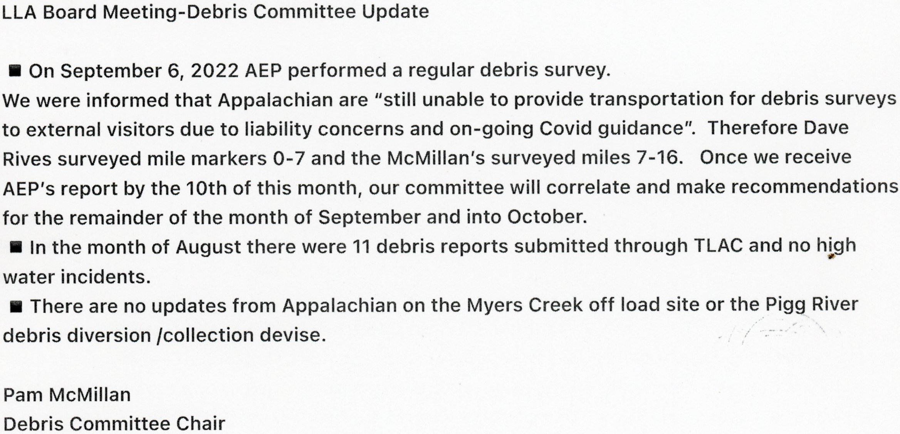

Membership: No update to report.

Navigation: The Jasper Creek hazard buoy on the north side has disappeared. A search of the lake has not located it. The anchoring chain may be caught up in the rocks and holding the buoy submerged. Anyone out during low water level, please check for the buoy. The Myers Creek “island” buoy is also underwater. Joe will request help on a day that supports retrieval of the buoy.

Potential Hazard Buoy- TLAC received an inquiry regarding installing a No Wake Buoy at MM7 on the Pittsylvania County side. The homeowner’s dock is somewhat in a blind spot for those cutting close to that side at the lake bend. LLA (via Joe) advised:
- A Hazard Buoy may be more appropriate than a No wake Buoy. Either way, LLA will not get into issues involving specific dock issues regarding buoys. Anyone interested in applying for such a buoy should go through the existing TLAC process.

Property: Joe reported that the LLA pontoon boat trailer is not registered and has no title. No further action taken by the Board as it was felt obtaining a title and registration is not needed at this time. Reminder to turn off the depth finder in the pontoon boat. Joe Purchased more supplies and will be reimbursed.

Safety: No update to report.

Water Quality: Water monitoring efforts for 2022 continue in accordance with our 2022 MOA. In the fall we will continue sampling of the Pigg River, using the 2022 Pigg River Project Plan.

Current Water Quality health of LVL:
1) No overall health concerns for recreational use.
2) Two threats to the lake are evident and are being carefully monitored. These are:
a) low dissolved oxygen in the tailwaters from Smith Mountain Lake Dam
b) poor water quality of the Pigg River

Low Dissolved Oxygen:
Appalachian Power Company (APCo) sent LVL Association the “SMITH MOUNTAIN HYDROELECTRIC PROJECT July 2022 Monthly Water Quality Monitoring Report ES Project No.: 16402 Dated: 9/1/2022” in accordance with the Water Quality Monitoring Plan for the Smith Mountain Project. The July 2022 Monthly Water Quality Report results show data from Instantaneous DO values ranged from 4.3 mg/L to 7.3 mg/L, with an average of 5.6 mg/L. Daily average DO values ranged from 4.9 mg/L to 6.4 mg/L, with a median daily average of 5.6 mg/L. Instantaneous readings were below 5.0 mg/l from 19-31 Jul 2022, with daily average readings below 5.0 mg/l on 25-26 Jul and 28-29 Jul. This is consistent with previous year observations.

APCO has initiated Phase 3 of their Feasibility Study, which will:
1) evaluate the practicality, effectiveness and cost efficiency of methods that increases dissolved oxygen in the tailrace without causing other water quality issues (e.g., increased water temperature).
2) Determine life cycle costs and decide whether to act, or not.
3) The completion of the Feasibility Plan is timely as Appalachian’s VDEQ Virginia Water Protection Individual Permit No 08-0572 (Permit) expires on March 31, 2025. It is Appalachian’s intent to file for a new permit at least one year prior to the expiration date.
No preliminary insights have been provided by APCo.

The LVL WQ Committee will continue to work with APCo, TLAC, DEQ, DWR, and other regulatory agencies to achieve satisfactory DO levels in Leesville Lake.

2022 Pigg River Study
Tom Shahady, Tony Capuco and Charlie Hamilton will meet on 13 Sep to finalize the Pigg River sampling plan for September and October 2022. Bacterial Source Tracking (BST) will be conducted (3 host markers per sample) on 9 water samples focusing on the following analyses: Human-HF183 ddPCR, Cow-CowM2(EPA1), and Ruminant_Rum2Bac.

Our 2022 Pigg River Study Objectives are:
(1) Closely study the area between Chestnut Hill and Colonial Turnpike (the area implicated as contaminated with sediment from the Power Dam removal) to quantify the extent to which the sediment in this area impacts bacterial/nutrient/sediment water quality in the Pigg River.
(2) Identify sources of bacterial contamination by identifying the bacterial content of water during both low flow and storm events.
(3) Quantify the impact of this sediment by conducting sediment disturbance experiments (water collected before and after sediment disturbance) in conjunction with bacterial source tracking to specifically characterize how this underlying sediment contributes to bacteria in the water.
(4) Evaluate the efficacy of E. coli / Enterococci ratios in determining the source of bacterial contamination. We need to identify this impact to suggest management of sediment as it impacts water quality to Leesville Lake and continues its migration into the lake.

Special thanks to the LVL WQ Committee: Debbie Oliver, Kathleen Giangi, Dave Waterman, and Tony Capuco for their continuing hard work.

TLAC Update: The first No Wake Surfing Zone application has been approved on Smith Mountain Lake
- Threats for legal action about the approved zone
- Complex issue – discussion about the definition
- What is the definition of the problem? Large wakes in areas with floating docks regardless of the device that is behind the boat.
Other Items:
- The new TLAC budget was found to be in error resulting in approximately $9K in additional funding for LVL.
- The TLAC website is being updated. Dave Waterman should look at the TLAC website to see if there is anything we can add.
- LLA’s 2023 TLAC Representative must be approved by membership at the October Membership Meeting. As the LLA President, Dave R will continue in that role if the membership so desires. Nominations should be open from the floor and then the general membership needs to vote so it is properly recorded for Pittsylvania County and TLAC.

AEP Technical Review Committees: No reports to update.

Old Business:
Speakers for 2022/2023 Membership Meetings:
Next Meeting October – Mr. Tangier – Friends of the River of Virginia
AV Needs – Tony will coordinate AV Needs

Speakers for January
Fishing Tournaments? Other items

New Business: Email from the Altavista Journal – Leesville Lake Magazine – do we want to be in it? Dave R has a call into them for additional information. Communications Committee will ask to get involved once more is known.

Executive Session: No items to report.

Confirmation of the October Meeting: Phyllis has confirmed that the Train Station is reserved. The Directors were advised where to locate the key. The Board agreed to have a pizza social after the meeting. Pam M will coordinate and speak with Phyllis and Mary about how we have accomplished this in the past. Social Event After the meeting? Dave R will not be able to attend due to a previous commitment of a family reunion. Chip has the lead and has been notified. Dave R will put out an agenda prior to the meeting.

Adjourn:
Motion: All approved.

