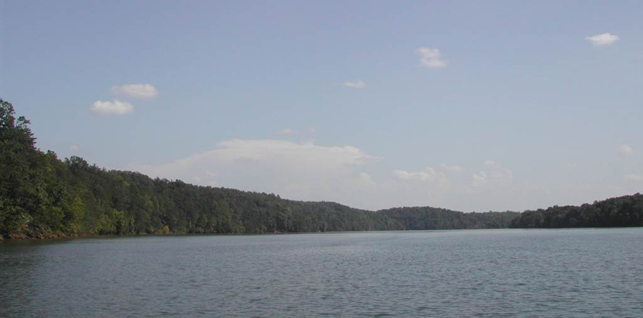
LEESVILLE LAKE ASSOCIATION’s
ANNUAL BEAUTIFICATION DAY
2nd SATURDAY in June (June 10th)

SPONSORSHIP FORM
PLEASE PRINT:
Company Name (exactly as you wish listed in sponsorship listings):
__________________________________________________________________________________
Company Representative: ____________________________________________________________
Address: __________________________________________________________________________
__________________________________________________________________________
Phone: ___________________________________ Fax: _________________________________
Email: ______________________________________
Donation Deadline is May 1st to guarantee Silver through Diamond listing on Beautification Day T-shirts. All sponsors receive recognition in LLA newsletter and at other events as well.
SPONSORSHIP LEVELS (select one)
- Diamond ($2,500 or greater)
- Platinum ($1,500 to $2,499
- Gold ($500 to $1,499)
- Silver ($300 to $499)
Any amount is always appreciated
Please remit to Leesville Lake Association. For in-kind service donations, please contact:
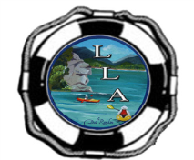
Email: treasurer@leesvillelake.org Website: https://leesvillelake.org/beautification-day/

Leesville Lake Association Point of Contact: Roy Kelley
PO Box 68 Email: beautification@leesvillelake.org
Altavista, VA 24517 Mobile: 703-919-0074

