Minutes of Board Meeting,
Leesville Lake Association, March 9, 2023, Altavista Public Library

Present: JW Burton, Tony Capuco, Cynthia Coleman, Glenn Coleman, Joe Humphrey, Roy Kelley, Mary Loiselle, Pam McMillan, Jeff Markiewicz, Dannie Smith, Dave Waterman

Absent: Dave Rives, Chip Zimmerman, Bill Beckett; Richard Beaton, Charlie Hamilton

Quorum: Yes

Call to order: Mary Loiselle called the Board meeting to order at 6:26 p.m.

Minutes: It was noted that Joe Humphrey was absent from the February 2023 meeting and not marked as such. Cynthia made the change. Mary asked for a motion to approve the minutes from both the February 9, 2023 Board meeting.
Motion: JW Burton made a motion to approve the minutes from the February 9, 2023 Board meeting as presented. Joe Humphrey seconded. All approved.

Treasurer’s Report: Bill Beckett was not present at the meeting but had sent everyone his report. Mary asked for a motion to approve the treasurer’s report.
Motion: Roy Kelley made a motion to approve the Treasurer’s Report as submitted. Pam McMillan seconded. All approved.

Committee Reports: Organizational Succession Planning
- Executive (Standing Committee) – Dave Rives
    - Dave Rives was not present, but the secretary position is still a big concern. Any feelers Cynthia has put out to new members hasn’t resulted in a bite of interest.
    - Annual Director Renewal Process: Discussion regarding those board members who would leave at the end of the term in 2023, of which there are seven, Beaton, Burton, Capuco, Humphrey, Loiselle, McMillan, Waterman. Mary suggested that if these members wish to come back to serve on the board a proposal should be written and presented at a board meeting.

- Finance (Standing Committee)
- Capital Improvement Ideas: nothing new
- 2022 Audit: Please find attached the signed letter that Davis Hewett and JW Burton submitted after they conducted the inspection of the financial records for 2021-2022.
- Regarding Beautification Day 2024, Mary stated that in March 2023 money is requested of TLAC’s financial support. Roy has not yet heard of a response regarding this but will follow up.

- Nominating: This committee needs a chair and two members. Currently, Glenn Coleman is a member of this committee, but a chair and one other member is needed.

- Beautification Day: The T-shirts on hand need to be inventoried as to number of shirts and in what sizes. The list of donors needs to be completed by May1. And the flyers need to be passed out and posted.

- Communications:
- Website: Dave Waterman reported there was nothing new regarding the website.
- E-Newsletter: Next articles due March 15, 2023
- Calendar (Phyllis Garlick / Joni Pauley) More photos for the calendar are requested
- Email (Frank Podrebarac) Nothing new to report

- Debris: Pam McMillan had no updates.
2023 Overall Plan:
    - Pam is to receive updates from Liz Parcel on either 10 or 11 March, 2023, after this meeting
    - Pigg River Collection/Diversion Project Technical Evaluation: Appalachian has not given us any new updates regarding this Project.
    - Pam asked the board if at any time they reported debris throughout 2022, that they had received any call backs from Appalachian confirming their reports. The answer was a unanimous no. Pam said that AEP plans to train an employee and to start back up that courtesy starting April 2023.
    - Pam asked Roy as to how many signed up for Beautification Day 2022. Roy replied an estimate of 60 stakeholders signed up. Pam made the distinction that 60 Leesville Lake participants on one day, for approximately 5 hours, collected 47 tons as opposed to Smith Mountain Lake whose cleanup involved the whole month of May, had an estimate of 128 participants covering 25.4 miles, and only resulted in 4 tons of debris removal.

- Membership: Cynthia Coleman
  - Current membership is at 221 households
  - Regarding the APLOS “scrub,” Cynthia has been working through the membership list checking for duplicates and working with Diane through sending her the new members’ emails, and reviewing Diane’s newsletter list to match it with what is in APLOS
  - LLA merchandise:
    - Cynthia brought a T-shirt with a detailed map of the lake on it that she had found online and purchased at $19.95.
    - Board members present liked the T-shirt and thought it would be a good one to sell
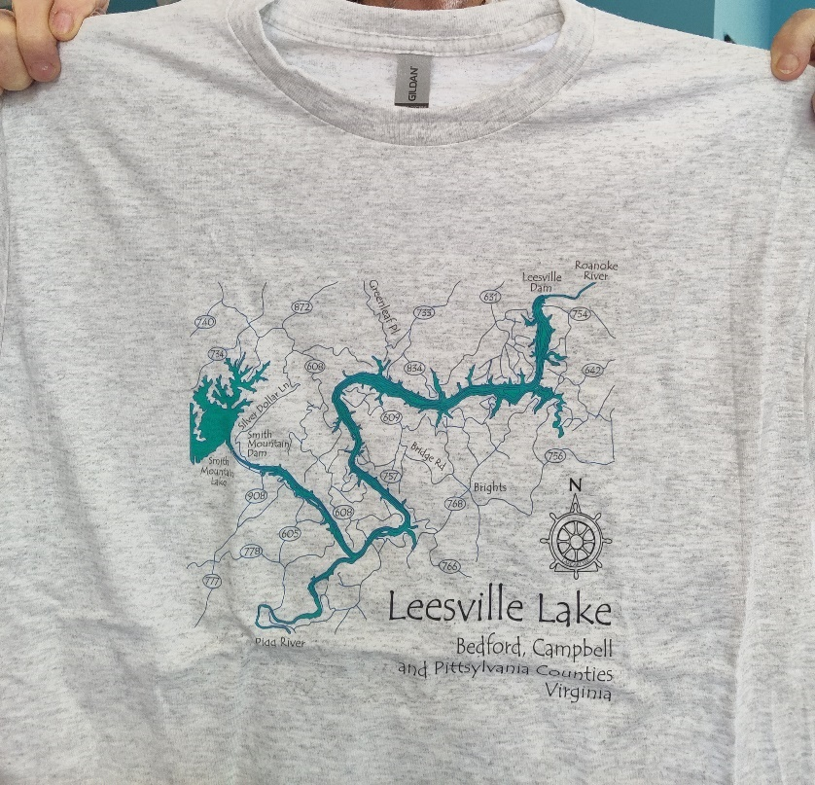
    - Cynthia brought up the idea of having a membership contest to design a ballcap to also sell. There was discussion regarding using the many logos LLA already has. Cynthia thought the “contest” would be a way to build community within the membership and will bring a proposal to the board regarding this.
    - Cynthia asked if she could send out handwritten notes to the members who don’t have emails to see if they would like to theirs added to their account so they could receive email communication, such as the newsletter, from LLA. Mary said there is a membership line item on the budget and Cynthia needs to contact Bill regarding any funds for this and any other membership project.
    - 2023 Annual Meeting: Pam and Cynthia volunteered to organize the annual meeting, which will be held on the third Saturday in July, this year July 15, 2023

- Navigation: Joe Humphrey
1. Hazard Markers Update: The DWR Annual Notice will be in place on April 1, 2023
2. APCo Aids to Navigation Plan Update: According to the original schedule, there were to be 43
navigational aids on the lake. Leesville Lake Association submitted a proposal for only 13.
According to Liz Parcell, the Coast Guard review of the proposed navigational aids will take place in either April or May.

- Property: Open
Joe Humphrey stated that the pontoon boat is still on the trailer. He will look at the motor soon. Also, a tow bar and a cleat have been added.

- Water Safety: Jeff Markiewicz
  - 2023 Vessel Safety Inspections – Jeff Markiewicz is researching what qualifications he will need to be certified
  - 2023 Boater Safety Classes: Anyone interested will be referred to VA DWR
  - Lake “Rescue” Service: There is a preliminary investigation on what law and liability looks like, but there are no formal proposals as yet

- Water Quality: Charlie Hamilton LVL WQ Chair
All Water monitoring efforts for 2022 have completed, in accordance with our 2022 MOA. Budgeting activities have been submitted to APCo and TLAC for 2023/2024 Water Quality initiatives. APCo 2023 LVL work Plan submitted to APCo on 2/11/2023. 2022 LVL Water Quality Annual Report submitted to APCo on 3/9/23. 2022 Pigg River study report is under review. Water Quality TRC 2 is scheduled for Friday 21 April at 1030. HDR (APCo subcontractor) will present Phase 3 Feasibility Study results. VDEQ will present the 401 Procedural Review Process (license). APCo Annual report for review expected week of 13 March.

Current Water Quality health of LVL:
- No overall health concerns for recreational use.
- Two threats to the lake are evident and are being carefully monitored. These are:
  - low dissolved oxygen in the tailwaters from Smith Mountain Lake Dam
  - poor water quality of the Pigg River

- TLAC Update: Dave Rives
- Meeting Update – February 14, 2023
  - 2023 Chair – Lori Smith, Vice Chair – David Rives
  - 2023 Budget Approved as amended
  - New By-Laws approved
  - SMLA Annual Meeting – June 10; please take note
- Next Meeting – April 11, 2023

- AEP
  - Technical Review Committee Update(s)
      - Review of 2022 FERC Annual Reports: Mary stated that LLA must review and make comment within 30 days. All drafts are to go to Dave R.
      - TRC Meeting(s)
1) Debris (Pam McMillan)
2) Water Quality (Charlie Hamilton)
3) Aquatic Vegetation (Lou Revelle)
4) Recreation (Chip Zimmerman)
          - Bank Fishing
          - Fishing Training for Kids
5) Navigation (Joe Humphrey)
6) Habitat (Richard Beaton)
  - Shoreline Management Plan Review (2024)
    - General Process June through October 2023: Do we need a committee for this to review?
    - TLAC and Associations involved

Old Business:
Speakers for 2023 Membership Meetings
    - April 15, 2023, 10:30 a.m. at the Altavista Train Station
      - Keith Roberts will speak as he fishes on Leesville Lake
      - His website is www.keithrobertsfishing.com
- July—AEP/APCo has been confirmed.
- October—Lou Revelle on indigenous populations along Leesville Lake and area.

New Business:
- Dave R sent the question to the board: Should APCo Representative attending our meetings?
- Dave W reported that some people have had a difficult time with the LLA website and that it is due to the low bandwidth

Confirmation of next meeting: Membership Meeting, April 15, 2023, 10:30 a.m., at the Altavista Train Station
    - Speaker – Keith Roberts
    - Refreshments -

Adjournment: At 7:55 p.m. Jeff called for the meeting to be adjourned, which was seconded by Tony. All agreed.

