Minutes of Leesville Lake Association
Board of Directors Meeting, June 8, 2023, Altavista Train Station Picnic Pavilion

Present: President Dave Rives, Vice President Chip Zimmerman, Treasurer Bill Beckett, Directors JW Burton, Tony Capuco, Cynthia Coleman, Charlie Hamilton, Jeff Markiewicz, Roy Kelley, Mary Loiselle, Pam McMillan, Dannie Smith, Dave Waterman and Committee Chair Glen Coleman.
Absent: Directors Joe Humphrey and Richard Beaton.
Quorum: Yes
Call to order: Dave Rives called the Board meeting to order at 6:32 pm.

Minutes: Dave Rives asked for a motion to approve the May 11 meeting minutes of the Board. JW Burton made a motion that the minutes be approved. Bill Beckett seconded the motion. The motion was approved.

Treasurer Report: Bill Beckett
The water quality payment from AEP has been received and deposited. University of Lynchburg will now be paid for their 2022-2023 report.
The Year-to-Date Budget report, Income Statement, and Balance Sheet for May were submitted via email on June 7. Dannie Smith made a motion to approve the May Treasurer’s Reports as submitted. Chip Zimmerman seconded the motion. The motion was approved.

Committee Reports:
a. Executive - Dave Rives – no report
b. Finance - No report
c. Nominating –
i. New Directors for FY23/24 – Nominations will be open at the annual meeting in June. Elections will take place at the same time.
ii. 2023 2-year term directors retiring – Beaton, Burton, Capuco and Humphrey.
iii. FY 23/24 Leadership-
- Officers: Vote at the August BOD meeting. Known vacancies : President, Secretary
- Vacant Committee Chairs needed for: Finance, Navigation, Nominating and Property.
iv. TRC representatives are needed for FY 23/24 for Navigation and Erosion/Sedimentation
v. TLAC Committee representatives are needed for FY 23/24: Navigation

d. Beautification Day - Roy Kelley
Saturday, June 10, 9:00 AM to 1:00 PM
Thus far, 53 volunteers and 9 boats have signed up to help. Dumpsters will be delivered on Friday, June 9 to Tri-County and Leesville Lake Marinas. The t-shirts have arrived and will be distributed to volunteers. Signs have been put up at the drop-off locations and a message has been sent to AEP to maintain the lake water level at the 608-610’ level for ease of getting debris.

e. Communications - Dave Waterman
Newsletter articles due by June 15. We’re still looking for someone to pen articles on lake fishing.

f. Debris - Pam McMillan
Our Committee has not yet received Appalachian’s May/June monthly survey report. When we do, this will include results from the more recent High Flow event that occurred on May 28th when the Pigg River crested to 8.07 feet. In their report it will remain to be seen if Appalachian increased crew hours and escalated efforts to address not only this event but the HF event results on April 28th when the Pigg River crested at 10.5 feet.
- 2023 Overall Plan Compliance - It remains to be seen, however Dave Rives working on formulating data in chart form to demonstrate trends in performance (see ii. Below). What we do know is that neither Appalachian or the contractor have been up above MM 10 since March 24, 2023.
- TLAC is trying to coordinate a meeting with AEP and LLA prior to the LLA annual meeting on July 15. President Rives is encouraging the board and all members who attend the annual meeting to “disagree without being disagreeable.” He is prepared to highlight: 1) FERC requirements of AEP; 2) a chart of hours worked vs. hours promised; and 3) other data AEP reports to highlight discrepancies in their efforts.
iii. Myers Creek Offload Site Update- No Update
iv. Pigg River Collection/Diversion Project Technical Evaluation Update- No Update

g. Membership - Cynthia Coleman
i. LLA currently has 226 member households (+2).

ii.Cynthia sent the link to a Leesville Lake apparel website prior to the meeting. It appears to work with no issues so it will be put on the LLA website and announced at the annual meeting.

- Annual meeting – Venue and caterer have been set (Leesville Lake Marina for both) and notice has been put on the LLA website, with a request to respond regarding attendance and the number attending.
Booth Leads: Welcome – Cynthia; Invoice/Dues – Bill; T-shirts – Roy; Art Work – Bob Rankin
Set Up team – the board is on standby for Pam to notify us of when and where to report to set up the tent, tables and chairs. We may need to rent and/or borrow tables and/or chairs. Chip will determine and handle it, based on the anticipated attendance. AEP has confirmed a guest speaker. Dave will send a draft agenda out beforehand. There will be an introduction of the FY 23/24 returning directors; recognition of retiring directors; nominations for new directors; review and approval of FY 23/24 budget and brief committee updates. Bill will have invoices for FY 23/24 dues.

h. Navigation - Joe Humphrey (absent but sent a report)
i.Hazard Buoy Update- The 12 Hazard Buoys planned and approved are all in place.
ii.Aids To Navigation - The planned Coast Guard survey to review our 13 proposed navigation aids has been
postponed until July.

i.Property - The LLA pontoon boat is back in the water.

j. Water Safety - Jeff Markiewicz
i. Boater Safety Classes – under the auspices of DWR and the Coast Guard Power Squadron, the class schedule for June and July as been posted online.
ii. Lake “Rescue Service” review – Jeff is composing a draft proposal regarding LVL response (not rescue) service. The draft will be circulated to board for comments and input prior to posting online and sent to members.
iii. Electical Safety on Docks/Piers – a link to an article on electrical shock drownings will be put in the next newsletter and on the LLA website.

k. Water Quality – Charlie Hamilton
All Water monitoring efforts for 2023 have commenced, in accordance with our 2023 MOA. WQ Sampling team did the June sampling Monday June 6th. APCo provided the 2023 LLA WQ check of $36,887.00 In accordance with our University of Lynchburg MOA, $26,917.50 has been sent to University of Lynchburg to fund 75% of 2023 activities.

Current Water Quality health of LVL:

- No overall health concerns for recreational use.

- Two threats to the lake are evident and are being carefully monitored. These are:

- Low dissolved oxygen in the tailwaters from Smith Mountain Lake Dam. Appalachian’s VDEQ Virginia Water Protection Individual Permit No 08-0572 (Permit) expires on March 31, 2025. LLA has communicated to APCo and FERC that APCo’s resolution of the DO challenge should be central to whether Permit 08-0572 is renewed, or not.

- Poor water quality of the Pigg River (subject to 2023 studies)

Of note, Smith Mountain Lake is now experiencing a harmful Algal bloom, as reported by Virginia Department of Health:

Published: Jun. 6, 2023 at 6:54 PM EDT
MONETA, Va. (WDBJ) - The Virginia Department of Health (VDH) issued a statement about a harmful algal boom (HAB) in the Blackwater River arm of Smith Mountain Lake in Bedford, Franklin, and Pittsylvania counties.
The VDH warns people and pets to avoid contact with water including activities such as swimming, windsurfing, stand-up-paddle-boarding, and any activity that increases the risk of ingesting water. However, boating may continue with precaution in the advisory area.
“Some harmful algae, called cyanobacteria, can cause skin rash and gastrointestinal illnesses, such as upset stomach, nausea, vomiting and diarrhea,” the VDH added.
A Message from Chief Ohlerich:
Many of you are starting to see a blue discoloration in coves and along the shoreline over the last week. Your SML Fireboats have been out to check on it along with DEQ and VDEM-Haz Mat. We are told that this is an algae bloom due to the current weather pattern. You will notice the water change color to a light blue or teal, appear to have a scummy top layer, and have a smell associated with it.
Please refer to the following statement put out by VDH:
If you should see a change in your water quality - avoid contact (people and pets) with water that has discoloration, or scum on the surface, or water where there are dead fish or other aquatic organisms.
You may use the following link to send a report to VDH, so they can keep track of where it is on the lake. It is good to attach pictures of what you are seeing.
https://www.vdh.virginia.gov/…/harmful-algal-bloom-online…/…
Thank You,
Chief Todd Ohlerich
Smith Mountain Lake Marine Vol. Fire Dept.

ALGAL BLOOM SURVEILLANCE MAP

The map is updated regularly during the months of May – October. The HAB Task Force responds to complaints regarding blooms. The map does not reflect all possible blooms in the state, only those reported and under investigation.
The HAB Task Force does not have the resources to provide response support to bloom reports on privately owned waterbodies, therefore those blooms will not appear on the HAB Map below. If you suspect a bloom on a private waterbody, please visit the Dept of Wildlife Resources list of Private Lake Management Firms page to find a consultant to provide HAB investigation support and utilize our Private Waterbody Manager’s Toolkit.
You may expand the map to make it larger using the four corner symbol in the upper right hand corner of the map header bar. If you embed the map on your site, you must also add the legend on this page.
Once you expand the map, you may click on recent monitoring points, and click the magnifying glass in the search bar to search for landmarks and addresses to see if there are harmful algae blooms nearby.
How do I report an Algal Bloom or Fish Kill?
To report an algae bloom, visit our online HAB report form. If you are concerned that you have been exposed to a harmful algal bloom, please contact your health care provider. Telling your your provider about contact with water may help them diagnose the illness properly. Reporting human or animal HAB-related illnesses using the HAB Hotline (below) will ensure we can report cases to the Centers of Disease Control and Prevention, which may help prevent illness of others due to exposure to the same waterbody.
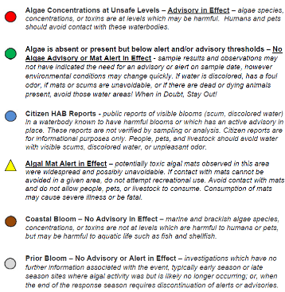 | Algal Bloom Surveillance Map - Waterborne Hazards Control  The map is updated regularly during the months of May – October. The HAB Task Force responds to complaints regarding blooms. The map does not reflect all possible blooms in the state, only those reported and under investigation. The HAB Task Force does not have the resources to provide response support to bloom reports on […]  www.vdh.virginia.gov

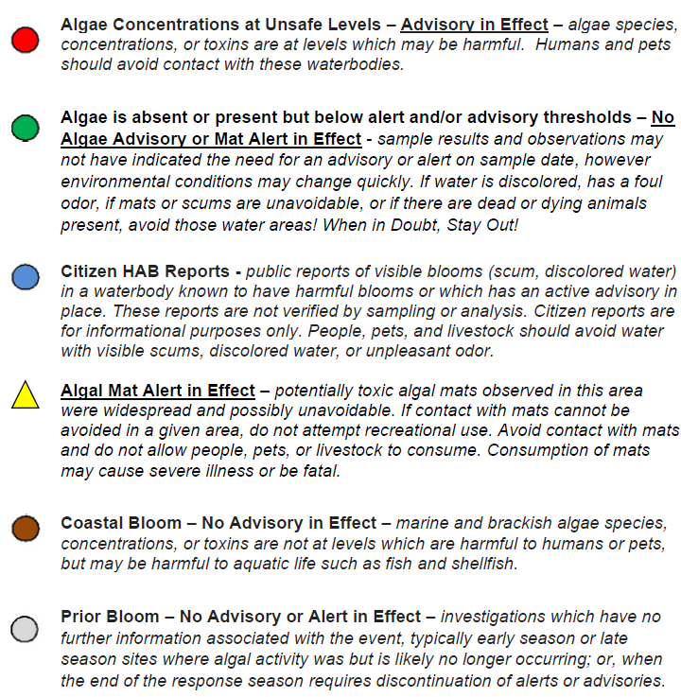

TLAC Update – none.

Old Business:
  - Speakers for 2023 Membership meetings:
    - July – AEP/APCO
    - October – none scheduled as of now, Lou Revelle is always a good standby speaker.
  - APCo representative attending our Board meetings.
    - Neil Holthouser is available for our September meeting.

New Business: None.

Confirmation of next meeting – place, date and time:
- Saturday, July 15, 2023 (Annual Meeting) – Leesville Lake Marina, 12:00 NOON
- Thursday, August 10, 2023 – Staunton River Memorial Library, 6:30 P

Adjourn:
Motion: JW Burton made a motion to adjourn the meeting. Charlie Hamilton seconded. The motion was approved, and the meeting adjourned at 7:41 PM.

