FISHING REPORT …

STRIPERS ... Late fall, winter, and early spring produces the most stripers in Leesville Lake. The stripers often follow the shad into shallow water during the night and early morning. Casting to these shad in the shallow shoreline in predawn or early morning can produce some nice fish (but most of us … including myself … will be in bed at that time, so we’ll never experience this thrill). The alternative is to troll in open waters (usually at 3/4 to 1 mph) in areas where fish are likely to be cruising. And THAT IS THE CHALLENGE in Leesville Lake striper fishing … LOCATING the stripers.

Trolling at 3/4mph is too slow to explore much water. One solution it to troll at higher speeds up to 2 1/2 or even 3mph WITH the larger size (vs casting size) UMBRELLA RIGS. Most stripers at this time of year are caught between the Leesville dam and Mile Marker 8 … that’s a lot of water! As the water warms the shad become more active and so do the stripers … using multiple poles and even planner boards allow for covering a lot of water … once a strike or fish is caught, focusing on that area can produce more fish.

Umbrella rig striper …

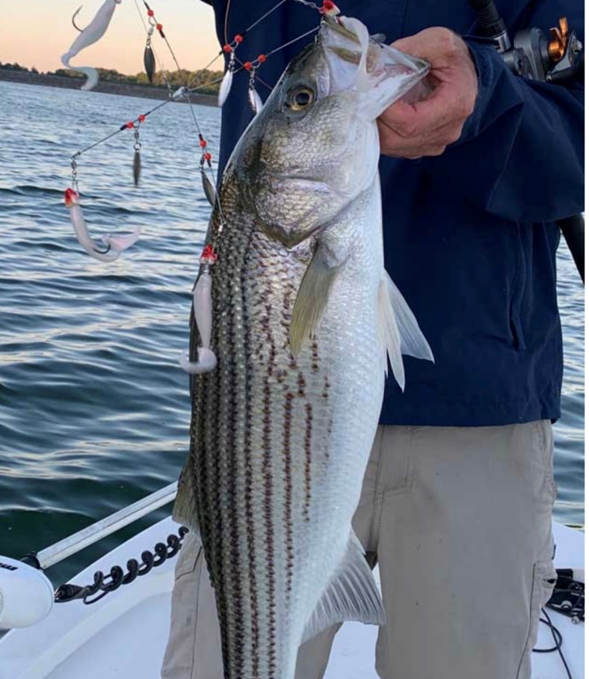

WHITE PERCH and CRAPPIE … Springtime is crappie time. Crappie go shallow to spawn as water temperature moves towards 60 degrees and they prefer to hold around some kind of structure. White perch are often caught in the same areas, but they are more prone to open water than crappie. A really productive way to fish these two species is to fish a “structure” for a MINUTE OR TWO and if no fish caught, move to the NEXT one. The Virginia Department of Wildlife Resources (DWR) has added another 26 FISH STRUCTURES to Leesville Lake recently to improve the “recruitment “of the fishery. If you don’t have a list of your favorite “structures “, try these for some fishing action (I have used these methods on the previously VDWR installed structures … always caught NICE fish at some of them ... only caution is there are a lot of worm robbing bluegills there too). The map with the location of the structures is shown below.

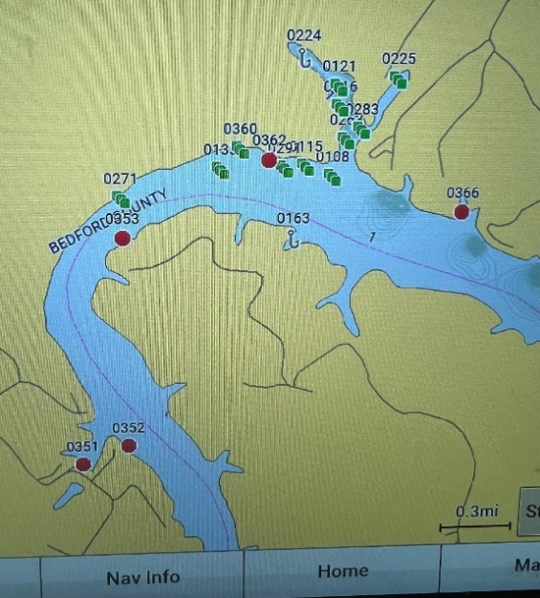
(Provided by Dan Wilson, Fisheries Biologist, VDWR, who led the team installing the “structures” and leads the netting surveying efforts (some results show below), among other activities on our lake.)
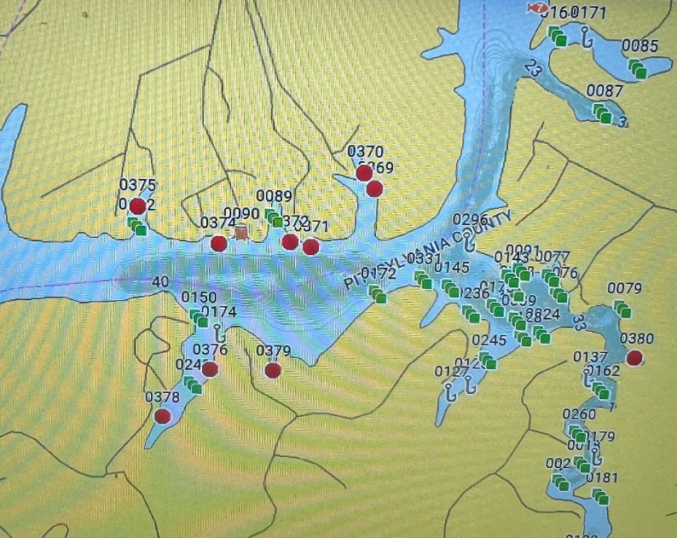
The RED DOTS are the FISH STRUCTURES (ignore the green 3 dots waypoints. It’s my personal info where I have caught 5 or more fish during a single trip … as one can see … there are a lot of fish in Leesville Lake).

HOW’s THE FISHING at LEESVILLE LAKE … The four charts below tell the story. Fishing in 2024 will be as GOOD or BETTER than the last couple of years (From a personal experience, 2022 and 2023 was the BEST FISHING 🎣 in my over 25 years on Leesville Lake).

As the charts show ... white perch, walleye and stripers are STABLE and channel cats are likely to be even more abundant (the absolute numbers are not very meaningful without some other reference data, BUT the TREND LINES tell story on what kind of fishing to expect!!!).

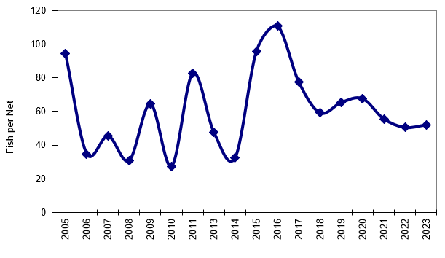

Figure 1. Leesville White Perch catch per net during DWR fall gill netting surveys.

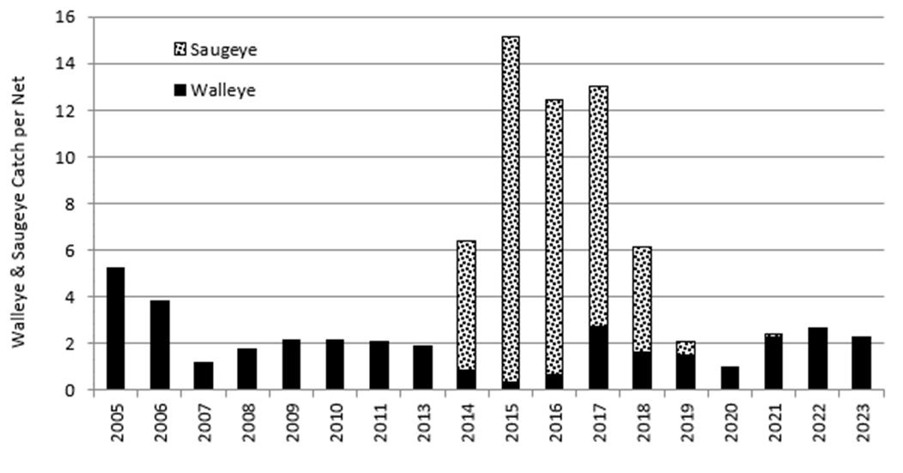
Figure 2. Leesville Walleye catch per net during DWR fall gill netting surveys.

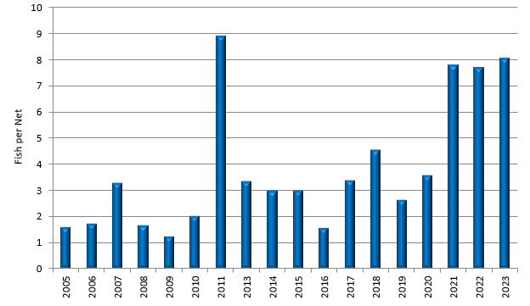

Figure 3. Leesville Striped Bass catch per net during DWR fall gill netting surveys.

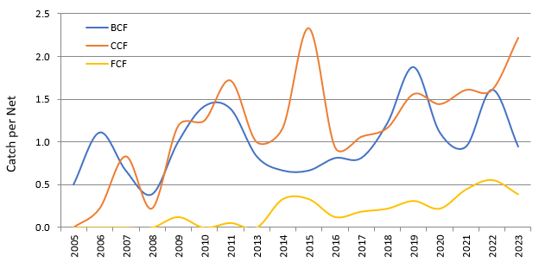

Figure 4. Leesville catfish catch per net during DWR fall gill netting surveys.

BCF = Blue Catfish
CCF = Channel Catfish
FCF = Flathead Catfish

BASS FISHING … Always decent on LEESVILLE LAKE.

In the spring time remember the saying of the OLD FISHERMAN … “REDBUDS START blooming, bass START spawning (move to the shallows) … DOGWOODS END blooming, bass END spawning (move off the spawning beds).”

GOOD FISHING……John Kese 434 942-1553

